**SPRINT 4**

|  |  |
| --- | --- |
| TEAM ID | PNT2022TMID50747 |
| PROJECT | Smart Waste Management System For Metropolitan Cities |

NODE RED UI:

Node-red-dashboard

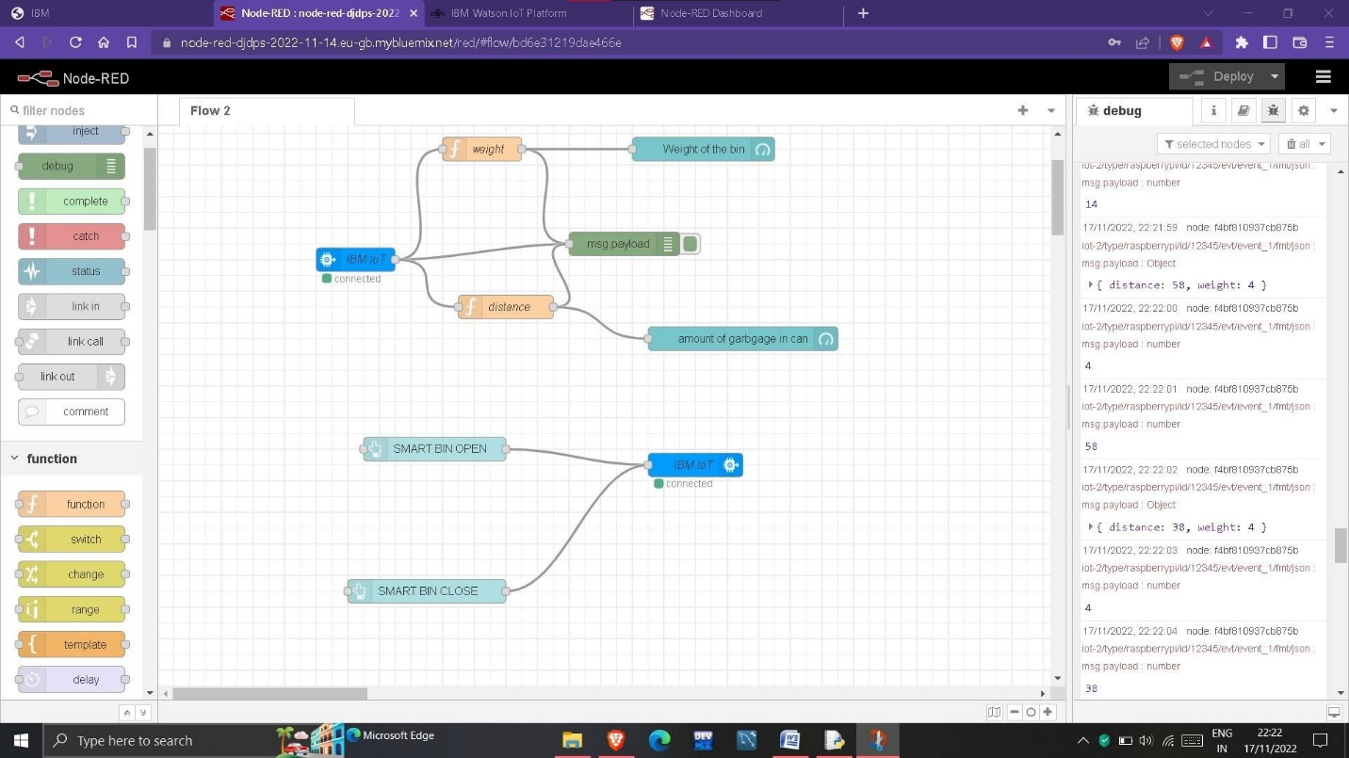

The data to nodes in the node-red are provided with the help of the python script via the ibm cloud which is considered to be the data from the data values from the sensor

To calculate the distance ultrasonic sensor is used, and as well as to calculate the weight weight sensor is used .

There are certain assumptions assumed by us, They are

* **The length of the trash can is assumed to be 200 cm.**
* **The maximum weight of the can is assumed to be 2 Kg.**
* **If the garbage distance goes more than 180cm i.e more than 90% of the trash can , the sensor is has to send to send an alert to the garbage collector.**
* **If the alert is received , then the garbage collector has to come and collect the garbage.**
* **The current weight and the garbage distance is to be updated periodically, i.e for 5 minutes**

FUNCTION CONFIGURATION FOR WEIGHT:

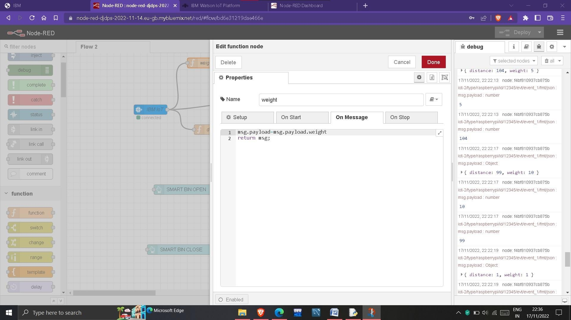

**FUNCTION CONFIGURATION FOR AMOUNT OF GRABGE IN CAN:**

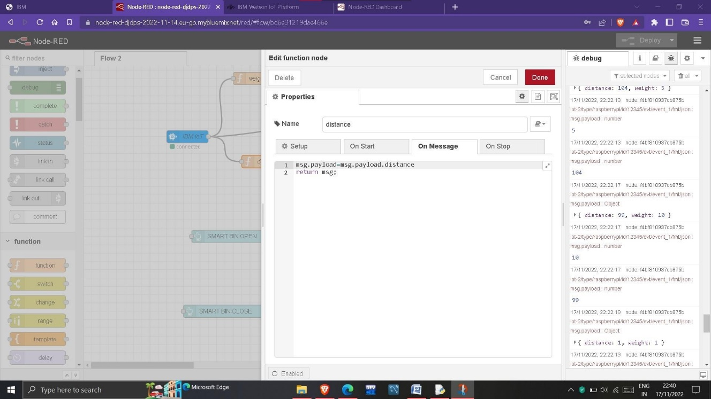

**UI :**

A simple web page which shows the amount of garbage in the smart bin and indicates free space in the trash bin. Then the web page also displays the weight of garbage present in the smart bin. It can hold a maximum of 10 kg and at the same time the length of the smart bin is 200 cm. A alert message is sent if the requirements are passed, and then the current co ordinates of the smart bin is being sent to the garbage collector .

The web page also composed of two buttons, with the help of the buttons we can open the smart bin and as well as close the smart bin . the command from the user is sent to the sensor and the dustbin is closed and as well as opened.

STORING THE DATA IN IBM CLOUDNT DB :

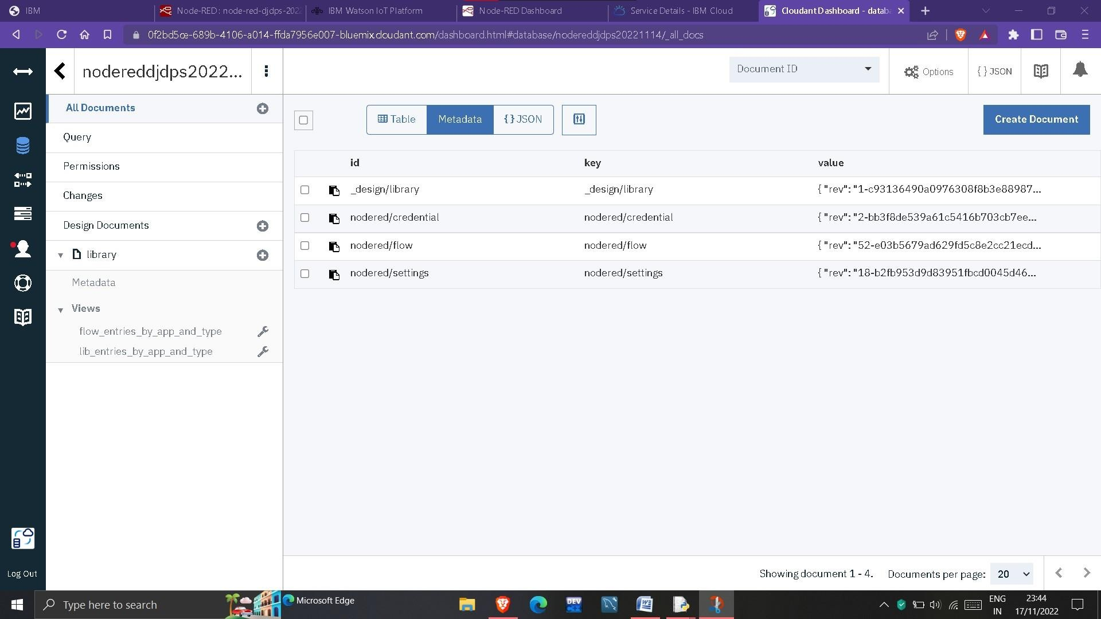

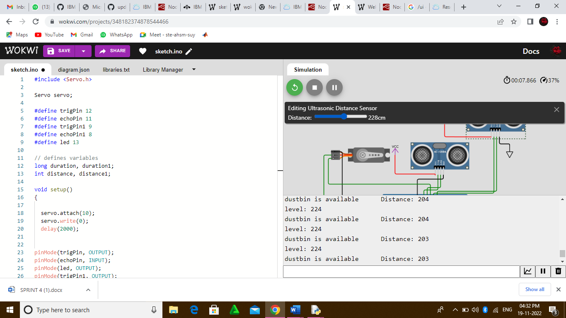

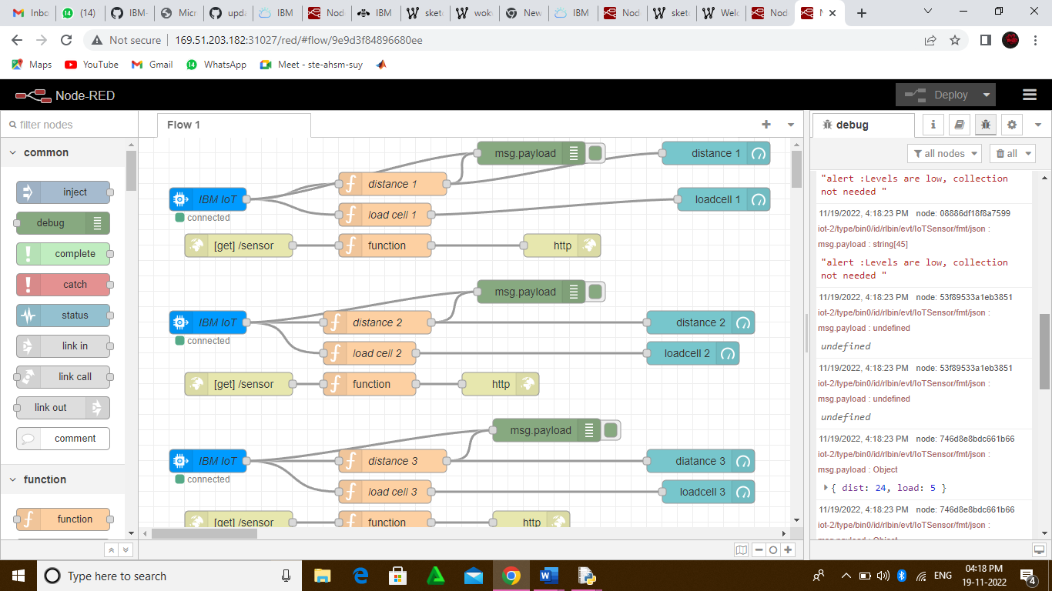

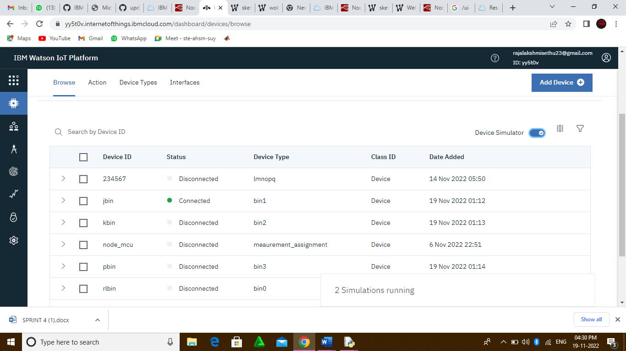

**WEB UI :**

Here the web page denotes the weight of garbage present in the smart bin and as

well as the, length of the smart bin filled with garbage in the above the current garbage

weight is 6 kg and as well as the length of smart bin filled with garbage is 200 cm .

There is button for smart bin processing, if we want to open and close the smart bin , we can perfom this with the help of the buttons .The data will be sent from the user interface to the sensors and the the required operation is performed .